To: Next Year’s Calculus BC Student

Attached is a summer homework packet, which will be due of the first day of Calculus class in August. The material in the packet should be material that you learned in Algebra II and Pre-Cal.

Grading: This packet will count for 2 homework grades, and some of this material may be on the first test.

Please be sure to review your unit circle. Your first round of pop quizzes will be on the unit circle. You should have the values of sin, cos, and tan memorized. (hint: make flash cards)

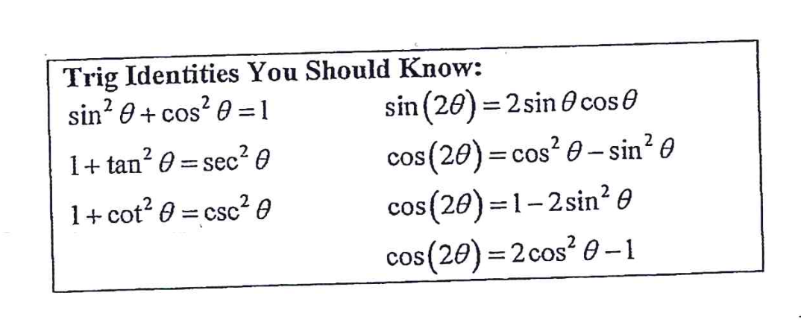

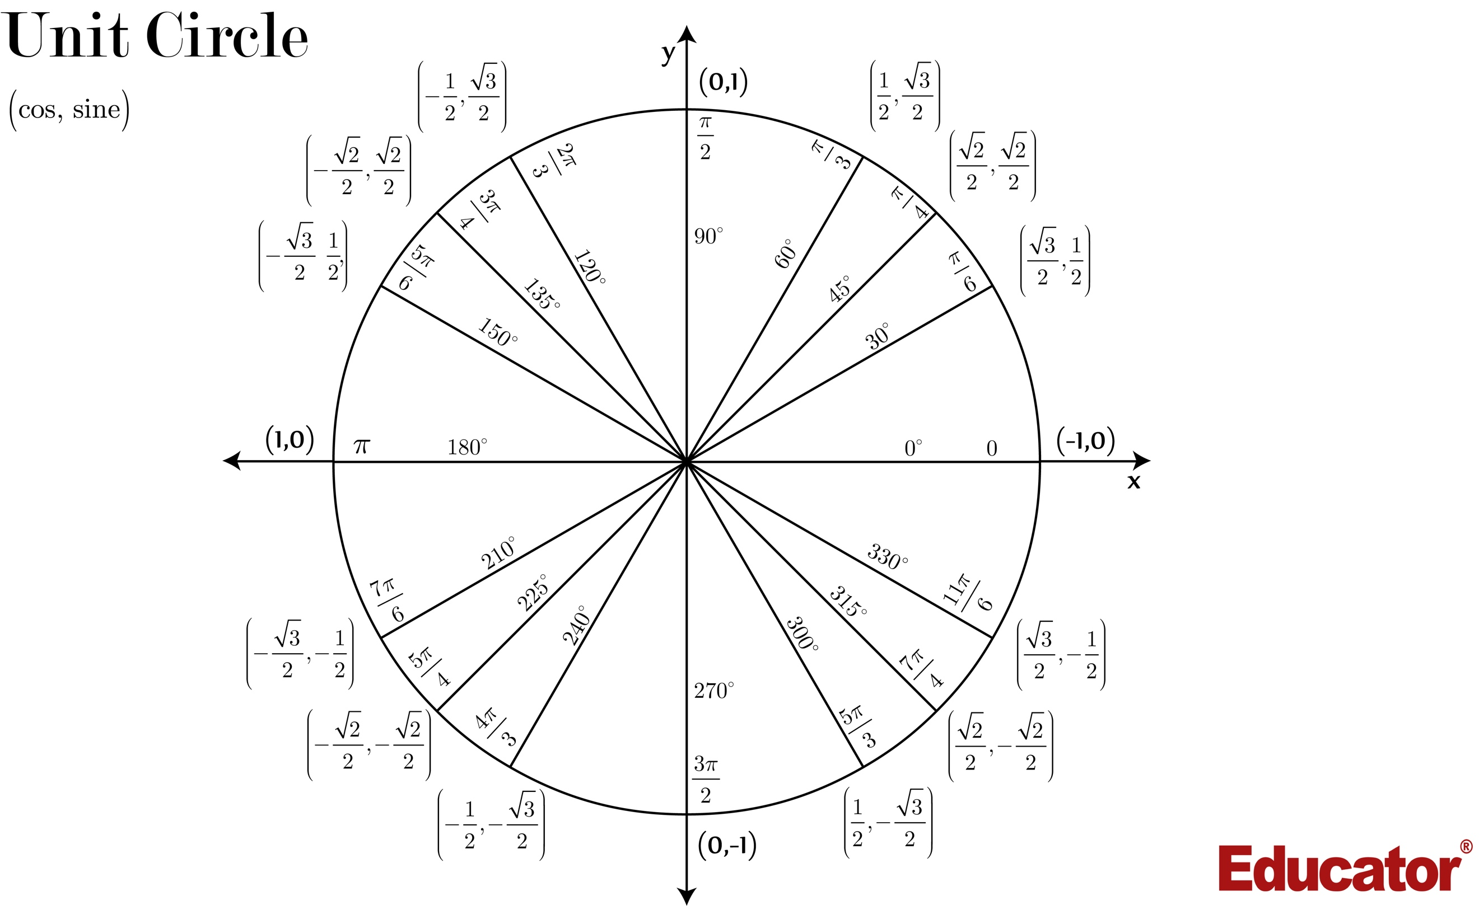

Directions: Again this assignment is due the first day of school! Work these problems on notebook paper.
All work must be shown to receive credit.

I) Find the x and y intercepts, the domain and range, and sketch the graph. No calculator

- $y=\sqrt{x-1}$
- $y=\sqrt{9-x^{2}}$
- $y=\frac{\left|x\right|}{x}$

- $y=\sin{x, -2π≤x≤2π}$
- $y=\cos{x, -2π≤x≤2π}$
- $y=\tan{x, -2π≤x≤2π}$

- $y=\cot{x, -2π≤x≤2π}$
- $y=\sec{x, -2π≤x≤2π}$
- $y=\csc{x, -2π≤x≤2π}$

- $y=e^{x}$
- $y=\ln{x}$

- $y=\left\{\begin{aligned}\begin{aligned}-1,if x≤-1 \\ 3x+2, if \left|x\right|<1\end{aligned} \\ 7-2x, if x≥1\end{aligned}\right.$
- $y=\left\{\begin{aligned}x^{2}+1, if x>0 \\ -2x+2, if x≤0\end{aligned}\right.$

II) Find the asymptotes (horizontal, vertical and slant), symmetry, and intercepts, and sketch the graph.
NO Calculator

- $y=\frac{1}{x-1}$
- $y=\frac{1}{{\left(x+2\right)}^{2}}$
- $y=\frac{2\left(x^{2}-9\right)}{\left(x^{2}-4\right)}$

III) Evaluate. NO Calculator.

- $\cos{\frac{5π}{6}}$
- $\sin{\frac{3π}{2}}$
- $\tan{\frac{5π}{4}}$

- $\sin{\frac{7π}{4}}$
- $\cos{π}$
- $\tan{\frac{2π}{3}}$

- $\sec{\frac{4π}{3}}$
- $\csc{\frac{π}{4}}$
- $\cot{\frac{2π}{3}}$

- $\tan\left(\cos^{-1}\left(-\frac{\sqrt{3}}{2}\right)\right)$
- $\sec\left(\arcsin\left(-\frac{\sqrt{2}}{2}\right)\right)$

IV) Solve. Give exact answers in radians, $0≤x≤2π$. NO Calculator.

- $2\cos^{2}x+3\cos{x}-2=0$
- $2\sin^{2}x-\cos{x}=1$
- $\sin\left(2x\right)=\cos{x}$

- $2\cos\left(2x\right)+1=0$
- $\tan^{2}x-\sec{x}=1$
- $2\cos\left(\frac{x}{3}\right)-\sqrt{3}=0$

V) Solve. Show all steps. Use your calculator, and give decimal answers correct to three decimal places.

- $e^{2x+3}=37$
- $e^{2x}-5e^{x}+6=0$
- $\frac{50}{4+e^{2x}}=11$
- $\log_{8}\left(x^{2}-3x\right)=1$
- $\ln\left(5x-1\right)=3$
- $\log_{8}\left(x+5\right)-\log_{8}\left(x-2\right)=1$

VI) Use the figure to find the limit. NO Calculator
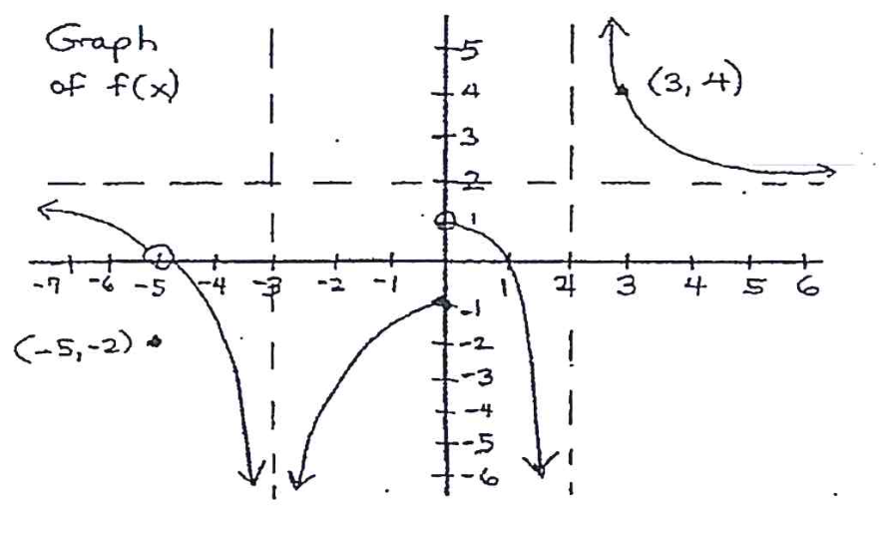

40. $\lim_{x→3}{f(x)}$ 41. $\lim_{x→∞}{f(x)}$

42. $\lim_{x→2^{+}}{f(x)}$ 43. $\lim_{x→0}{f(x)}$

44. $\lim_{x→-∞}{f(x)}$ 45. $\lim_{x→-5}{f(x)}$

VII) Evaluate. Show supporting work for each problem. (Algebraic steps or sketch) No Calculator.

46. $\lim_{x→-3}{\frac{x^{2}+x-6}{x+3}}$
47. $\lim_{x→0}{\frac{{\left(x-5\right)}^{2}-25}{x}}$

48. $\lim_{x→0}{\frac{\sqrt{x+1}-1}{x}}$

49. $\lim_{x→-6}{\frac{x+6}{x^{2}+3x-18}}$

50. $\lim_{x→-2}{\frac{x^{3}+8}{x+2}}$
51. $\lim_{x→∞}{\frac{{3x-5x}^{2}}{4x^{2}+1}}$

52. $\lim_{x→3^{+}}{\frac{1}{x-3}}$

53. $\lim_{x→3^{-}}{\frac{1}{x-3}}$

54. $\lim_{x→3}{\frac{1}{x-3}}$

55. $\lim_{x→3}{\frac{1}{{\left(x-3\right)}^{2}}}$

56. $\lim_{x→3^{+}}{⟦x-1⟧}$

57. $\lim_{x→3^{-}}{⟦x-1⟧}$

a) $\lim_{x→1^{-}}{f(x)}$ b)$\lim_{x→1^{+}}{f(x)}$ c) $\lim_{x→1}{f(x)}$

58. $f\left(x\right)=\left\{\begin{aligned}1-x, x≤1 \\ \\ x^{2}, x>1\end{aligned}\right.$

59) $f\left(x\right)=\left\{\begin{aligned}\frac{x^{2}-x-6}{x-3}, x≠3 \\ \\ 4 ,x=3\end{aligned}\right.$
a) $\lim_{x→3}{f(x)}$ b) $f(3)$

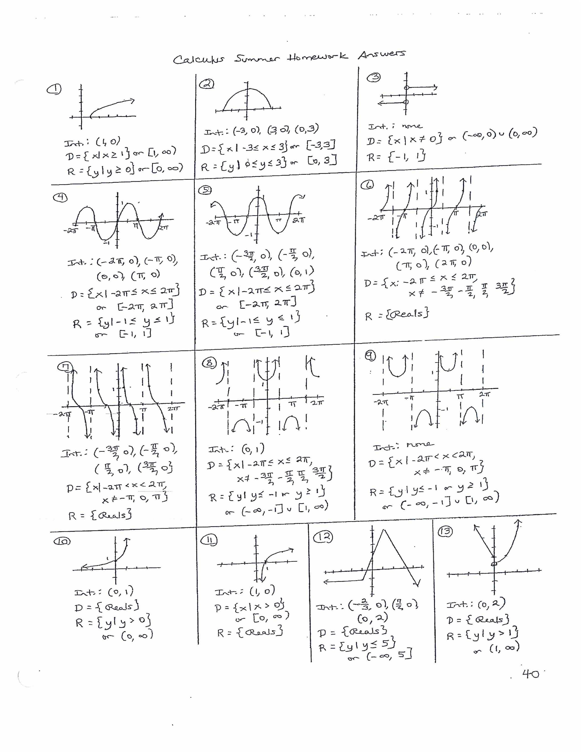
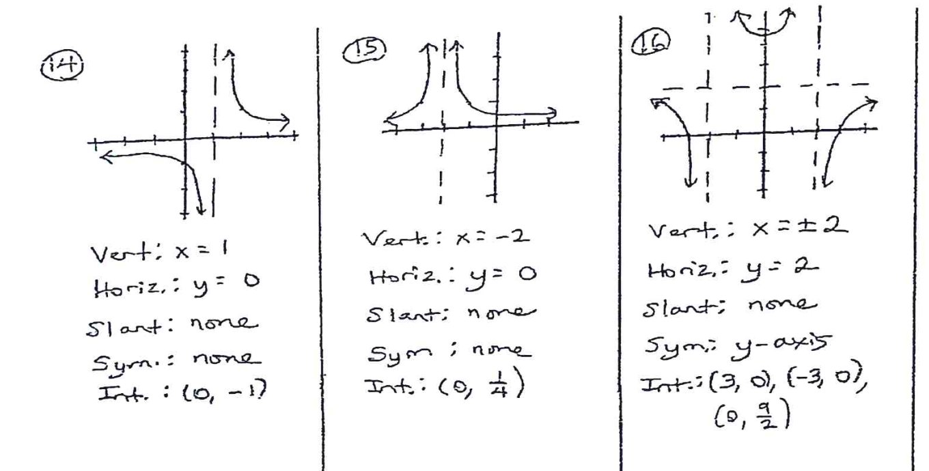

17. $-\frac{\sqrt{3}}{2}$
18. $-1$
19. 1
20. $-\frac{\sqrt{2}}{2}$
21. $-1$
22. $-\sqrt{3}$
23. $-2$
24. $\sqrt{2}$
25. $-\frac{\sqrt{3}}{3}$
26. $-\frac{\sqrt{3}}{2}$
27. $\sqrt{2}$
28. $\frac{π}{3}, \frac{5π}{3}$
29. $\frac{π}{3},π, \frac{5π}{3}$
30. $\frac{π}{6}, \frac{π}{2}, \frac{5π}{6}, \frac{3π}{2}$
31.$\frac{π}{3}, \frac{2π}{3}, \frac{4π}{3}, \frac{5π}{3}$
32. $\frac{π}{3}, π, \frac{5π}{3}$
33. $\frac{π}{2}$
34. 0.305
35. 0.693, 1.099
36. $-0.303$
37. $-1$, 4
38. 4.217
39. 3
40. 4
41. 2
42. $∞$
43. DNE
44. 2
45. 0
46. $-5$
47. $-10$
48. $\frac{1}{2}$
49. $-\frac{1}{9}$

50. 12
51. $-\frac{5}{4}$
52. $∞$
53. $-∞$
54. DNE
55. $∞$
56. 2
57. 1
58. a)0 b) 1 c)DNE
59. a) 5 b) 4

